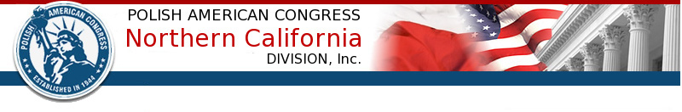
3765 Deer Trail Court, Danville, CA 94506
www.pacnorcal.org
pacnorthcal@yahoo.com
925-577 5256

Non-profit, volunteer run, since 1944

POLAND’S CONSTITUTION DAY
Dear Polonia and Friends of Poland:
Following an established tradition, the Polish American Congress of Northern California, will co-host with the Polish Folk Ensemble Łowiczanie the celebration of the 226th Anniversary of the May 3rd Polish Constitution, the first written constitution in Europe.
It is my pleasure to cordially invite you to the Annual Commemorative Concert to be held on Sunday, May 7th, 2017, 1-3 p.m., at the Band Shell of the Music Concourse in the Golden Gate Park in San Francisco.
The program includes Polish music performed by the Golden Gate Park Band, as well as songs and dances presented by Łowiczanie and two groups of children - “Sokoly”, Łowiczanie Dance & Music Ensemble for Kids, and “Orliki”, the Children’s Ensemble of the John Paul II Polish Language School which celebrates its 50-year anniversary.
It will be followed by a friendly get together at de Young café hosted by the Polish American Congress.
Your presence will make a difference!
Truly yours,
Andrzej Prokopczuk
President

