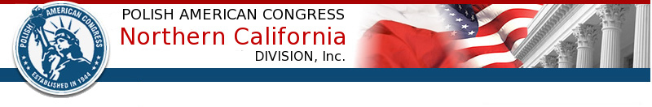
3765 Deer Trail Court, Danville, CA 94506
www.pacnorcal.org
pacnorthcal@yahoo.com
925-577 5256

Non-profit, volunteer run, since 1944

POLAND’S CONSTITUTION DAY
Dear Polonia and Friends of Poland:
Following an established tradition, the Polish American Congress of Northern California, will co-host with the Polish Folk Ensemble Lowiczanie the celebration of the 227th anniversary of the May 3rd Polish Constitution, the first written constitution in Europe.
It is my honor to request the pleasure of your company at the Annual Concert to be held on Sunday, May 6th, 2018, 1-3 p.m., at the Band Shell of the Music Concourse in the Golden Gate Park in San Francisco.
The program includes Polish music performed by the Golden Gate Park Band, as well as songs and dances presented by Lowiczanie and “Sokoly”, the Łowiczanie Children’s Ensemble.
It will be followed by a friendly get together at de Young café hosted by the Polish American Congress.
Your presence will make a difference!
Truly yours,
Andrzej Prokopczuk
President

